
Viewed by:
Yannick PETITBOIS
Tel.: +33 (0)2 99 27 92 92
E-mail: yannick.petitbois@iwedia.com

Written by:
Guy SCRUIGNEC
Tel.: +33 (0)2 99 27 92 92
E-mail: guy.scruigne@iwedia.com
IWEDIA

TDAL_DISP Technical Specifications

V1.7

Approved by:
Thierry GARNIER
Tel.: +33 (0)2 99 27 92 92
E-mail: thierry.garnier@iwedia.com

SUMMARY
1 Reference documents 4
2 Documentation History 5
3 Introduction 6
4 Module Overview and Architecture 7
4.1 Definitions, Acronyms and Abbreviations 7
4.2 General Description 8
4.2.1 Layer Z-Ordering 9
4.2.2 Layer windowing 10
4.2.2.1 Input aspect ratio and AFD 11
4.2.2.2 Blender Position and size 12
4.2.3 Interactions with other TDAL modules 18
4.3 Architecture 18
4.4 TDAL_DISP API Description 19
4.4.1 Generic Interface 19
4.4.2 Blender Interface 19
4.4.3 Layer Interface 19
5 TDAL_DISP API Specification 21
5.1 Type Specifications 21
5.1.1 Generic 21
5.1.2 Blender 21
5.1.3 Layer 21
5.2 TDAL_DISP API Usage 22
5.2.1 Blender Background colour set 22
5.2.2 Blender Z-order list set 23
5.2.3 Layer input/output windows set 24
5.3 TDAL_DISP Macro/Define/Enum/Typedef/Structure Definitions 25
5.3.1 Define Definitions 25
5.3.1.1 kTDAL_DISP_BLENDER_ZORDER_LIST_ENTRY_NULL 25
5.3.1.2 kTDAL_DISP_BLENDER_ZORDER_LIST_ENTRY_REMOVE 25
5.3.1.3 kTDAL_DISP_PIXEL_FORMAT_CLUT8 25
5.3.1.4 kTDAL_DISP_PIXEL_FORMAT_ARGB8888 26
5.3.1.5 kTDAL_DISP_PIXEL_FORMAT_AYUV8888 26
5.3.1.6 kTDAL_DISP_PIXEL_FORMAT_RGB888 26
5.3.1.7 kTDAL_DISP_PIXEL_FORMAT_YUV888_444 27
5.3.1.8 kTDAL_DISP_PIXEL_FORMAT_YUV888_422 27
5.3.1.9 kTDAL_DISP_PIXEL_FORMAT_ARGB4444 28
5.3.1.10 kTDAL_DISP_PIXEL_FORMAT_RGB565 28
5.3.2 Enum Definitions 29
5.3.2.1 tTDAL_DISP_AspectRatio 29
5.3.2.2 tTDAL_DISP_AspectRatioConv 29
5.3.2.3 tTDAL_DISP_Error 30
5.3.2.4 tTDAL_DISP_BlenderId 31
5.3.2.5 tTDAL_DISP_LayerId 31
5.3.3 Typedef Definitions 31
5.3.4 Structure Definitions 32
5.3.4.1 tTDAL_DISP_Capability 32
5.3.4.2 tTDAL_DISP_BlenderCapability 33
5.3.4.3 tTDAL_DISP_BlenderZOrderPositions 34
5.3.4.4 tTDAL_DISP_BlenderBackgroundColor 35
5.3.4.5 tTDAL_DISP_BlenderWindow 36
5.3.4.6 tTDAL_DISP_LayerCapability 37
5.3.4.7 tTDAL_DISP_LayerWindow 38
5.4 TDAL_DISP API Functions 39
5.4.1 Generic Interface API 39
5.4.1.1 TDAL_DISP_Init(-) 39
5.4.1.2 TDAL_DISP_Term(-) 40
5.4.1.3 TDAL_DISP_CapabilityGet(-) 41
5.4.1.4 TDAL_DISP_APIRevisionGet(-) 42
5.4.1.5 TDAL_DISP_PlatformRevisionGet(-) 43
5.4.2 Blender Interface API 44
5.4.2.1 TDAL_DISP_BlenderCapabilityGet(-) 44
5.4.2.2 TDAL_DISP_BlenderBackgroundColorSet(-) 45
5.4.2.3 TDAL_DISP_BlenderDimensionsGet(-) 46
5.4.2.4 TDAL_DISP_BlenderDimensionsSet(-) 47
5.4.2.5 TDAL_DISP_BlenderDisable(-) 48
5.4.2.6 TDAL_DISP_BlenderEnable(-) 49
5.4.2.7 TDAL_DISP_BlenderZOrderPositionsGet(-) 50
5.4.2.8 TDAL_DISP_BlenderZOrderListSet(-) 51
5.4.2.9 TDAL_DISP_BlenderDimensionsOutputSet (-) 52
5.4.3 Layer Interface API 53
5.4.3.1 TDAL_DISP_LayerCapabilityGet(-) 53
5.4.3.2 tTDAL_DISP_BlenderWindow 54
5.4.3.3 TDAL_DISP_LayerGlobalTransparencySet(-) 55
5.4.3.4 TDAL_DISP_LayerHandleGet(-) 56
5.4.3.5 TDAL_DISP_LayerIOWindowsAdjust(-) 57
5.4.3.6 TDAL_DISP_LayerIOWindowsAspectRatioParamsSet(-) 58
5.4.3.7 This function must be implemented if IsAspectRatioWindowConvCapable field is set to TRUE in tTDAL_DISP_BlenderWindow 59
5.4.3.8 TDAL_DISP_LayerIOWindowsGet(-) 61
5.4.3.9 TDAL_DISP_LayerIOWindowsSet(-) 62
5.4.3.10 TDAL_DISP_LayerDisable(-) 63
5.4.3.11 TDAL_DISP_LayerEnable(-) 64

Reference documents
The following documents were used to write this specification:

Document | Version | Title
[ETSI TR 101 154 ] | V1.7.1 | Digital Video Broadcasting (DVB);  Implementation guidelines for the use of Video and Audio Coding in Broadcasting Applications based on the MPEG-2 Transport Stream
[DTG implementation] | Issue 1.2.1 | DIGITAL TV GROUP – DTG Implementation and User Group – DIGITAL RECEIVER IMPLEMENTATION GUIDELINES and Recommended Receiver Reaction to Aspect Ratio Signalling in Digital Video Broadcasting – Issue 1.2.1 February 2001

Documentation History

History
Vers. | Date | Nature
1.0 | 02/05/2006 | GS: First version of TDAL_DISP
1.1 | 02/05/2006 | GS: Update after review  - Add TDAL_DISP_BlenderDimensionsGet(-).  - Add aspect ratio and AFD concept.  - Add TDAL_DISP_LayerIOWindowsAspectRatioParamsSet(-).
1.2 | 05/05/2006 | GS: Add AFD codes, updates with new aspect ratio conversions, remove full screen mode in layer window defintion.
1.3 | 15/06/2006 | GS: Add TDAL_DISP_LayerDisable/Enable(-) functions.
1.4 | 06/07/2006 | DUF: Add TDAL_DISP_APIRevisionGet(-) and TDAL_DSIP_PlatformRevisionGet(-) functions.
1.5 | 19/09/2006 | GS:  - Add constant kTDAL_DISP_BLENDER_ZORDER_LIST_ENTRY_REMOVE.  - Remove constant kTDAL_DISP_PIXEL_FORMAT_CLUT8.
1.6 | 28/01/2009 | YP :  - Add TDAL_DISP_BlenderDimensionsOutputSet
1.7 | 07/04/2009 | LO :  - Add use cases for the blender  - Add comedia blender values

Introduction
The purpose of this document is to specify the interface and to describe the internal design of the Thin Driver Adaptation Layer Display [TDAL_DISP]. The aim of this module is to provide a complete interface between middlewares and the video display output stage low level driver of a set-top-box.

Module Overview and Architecture

Definitions, Acronyms and Abbreviations
AFD | :Active Format Description –It is a data structure standardized in DVB that describes what portion of the picture actually contains useful information.
CVBS | :Composite video
YC | :Another name for S-Video
S-Video | :Separate video with two signals (brightness and colour)
YUV | :Luminance and colour difference signal in component video system
RGB | :Red-Green-Blue
SD | :Standard Definition
HD | :High Definition
OSD | :On Screen Display

General Description
The main job of the TDAL_DISP is to control video display output stage of a set-top-box at video presentation level.
Some general descriptions need first to be done.
A variable number of Layers are available depending on the hardware capabilities. Each Layer contains a video image (video, graphics or OSD, still-picture, …).
There are two kinds of Layers which are multi-region or not. The regions are areas in a layer where video images can be displayed separately. Typically, a video Layer is mono-region and a graphics Layer is multi-region. It is not in the scope of TDAL_DISP to manage regions.
Then, several Layers are linked together to a Blender.
The Blender is responsible for mixing several Layers with a possible configurable z-list order depending on the hardware capabilities.
The disposal of Layers are made on the Blender according to their output window coordinates. This disposal is considered to be virtual which means that no physical memory is associated with this disposal. If, depending on the hardware, there is memory associated with this disposal, it is not accessible to the TDAL_DISP client.
The Blender dimensions correspond to the video SD or HD standards currently used on the video outputs.
The Blender z-list is an array of Layer identifiers. The first identifier in the array is a z-order of zero which is the furthest Layer from the viewer. Subsequent identifiers increase the z-order.
The following example shows the Still/Video/OSD Layer blending on YUV/HDMI/CVBS outputs.
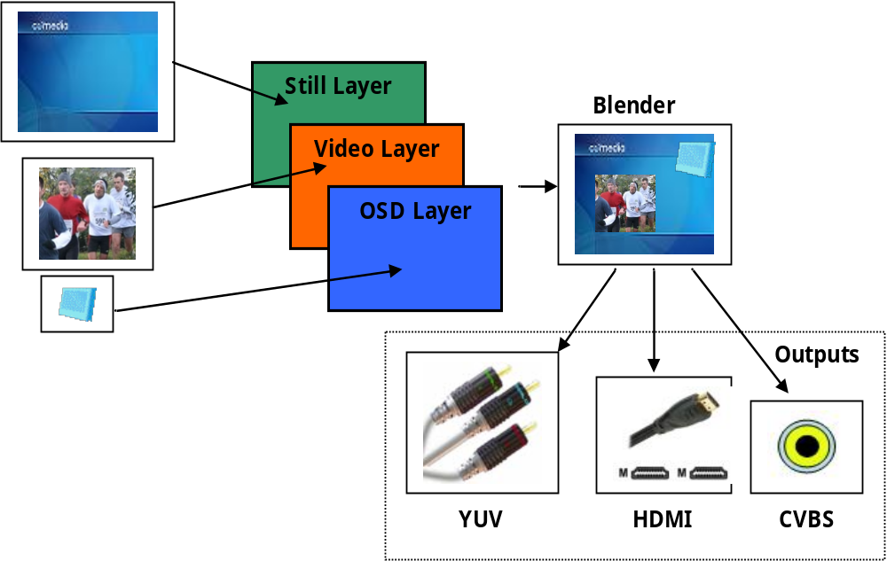

Layer Z-Ordering
Depending on hardware constraints, the link between blenders and layers is more or less configurable. Some hardware will have a complete fixed configuration where layers and blenders are tied together. Some others will provide the possibility to change only the Z-order position of layers on a blender. And some others will authorize the switch of layers between different blenders.
In order to have flexibility, TDAL_DISP defines the concept of blender layer Z-order list. It is an array of layer identifiers. The size of the array depends on the capabilities of the blender. The 1st layer identifier in the array (at index 0) represents the layer which is furthest from the viewer. Subsequent layer identifiers represent layers more and more near to the viewer.
The TDAL_DISP client can have the list of layer Z-order list combinations by getting the possible indexes that a layer can take in the Z-order list array of a blender.
If an unique layer can be set in different blender Z-order lists, it is not possible to set this layer in more than one blender Z-order list at the same time.

Layer windowing
TDAL_DISP provides the functionality to adjust input and output windows of a layer. Windows are defined using pixel coordinates.
The 1st pixel has a coordinate of x=0 and y=0. It corresponds to the top left corner of the window.
The input window corresponds to the totality or a part of a source (video or bitmap) stored in memory. The x, y positions of the input window is relative to the source total size.
The output window corresponds to the area positioned on the blender. The visual result depends on hardware and software scaling capabilities. For example, if the output window is defined outside the total blender size, the output window is clipped.
The following picture illustrates the concept of input/output windows:

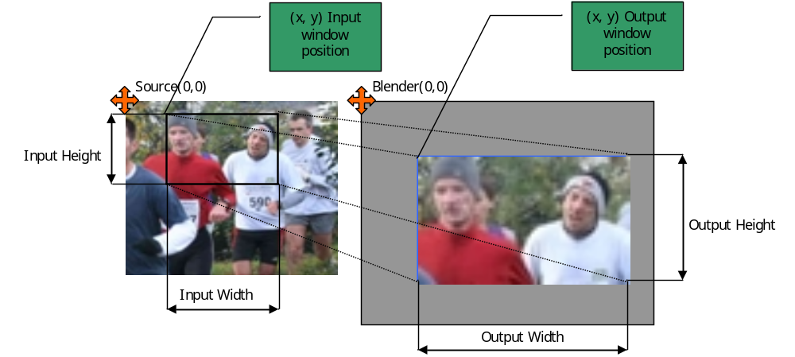
The layer capabilities indicates if input and/or output windowing is available.

Input aspect ratio and AFD
For video layers and because all manufacturers do not want to follow [ETSI TR 101 154] and [DTG Implementation] documents, the choice is let to TDAL_DISP implementers to do or not the window output resize calculation depending on video input size, its aspect ratio, its AFD code and the aspect ratio conversion mode. This ability is indicated in layer capabilities.
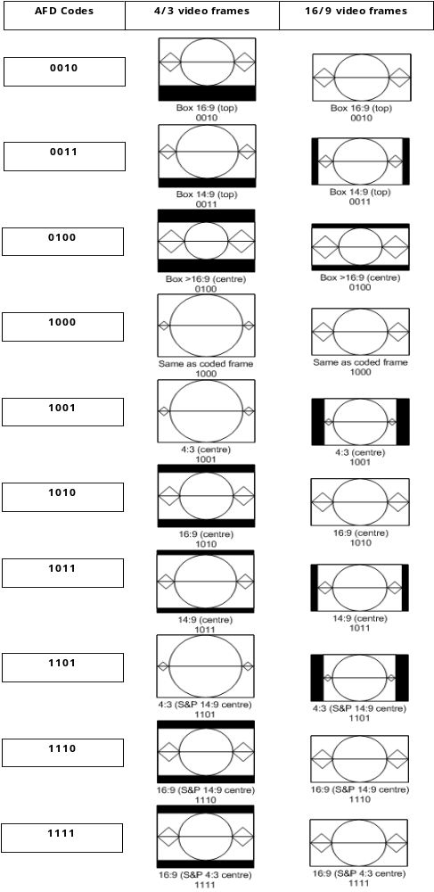

Blender Position and size
As Layer window output indicates the layer position and size inside a blender, blender window indicates where the blender will be placed on screen.
TDAL_DISP_BlenderDimensionsOutputSet function is used control this coordinates.
Typically, this function is called to simulate the Wide Screen Signalling alignment on HD output.

Use case 1
TDAL_DISP_LayerIOWindowsSet with input and output windows as shown below for both video and GFX.

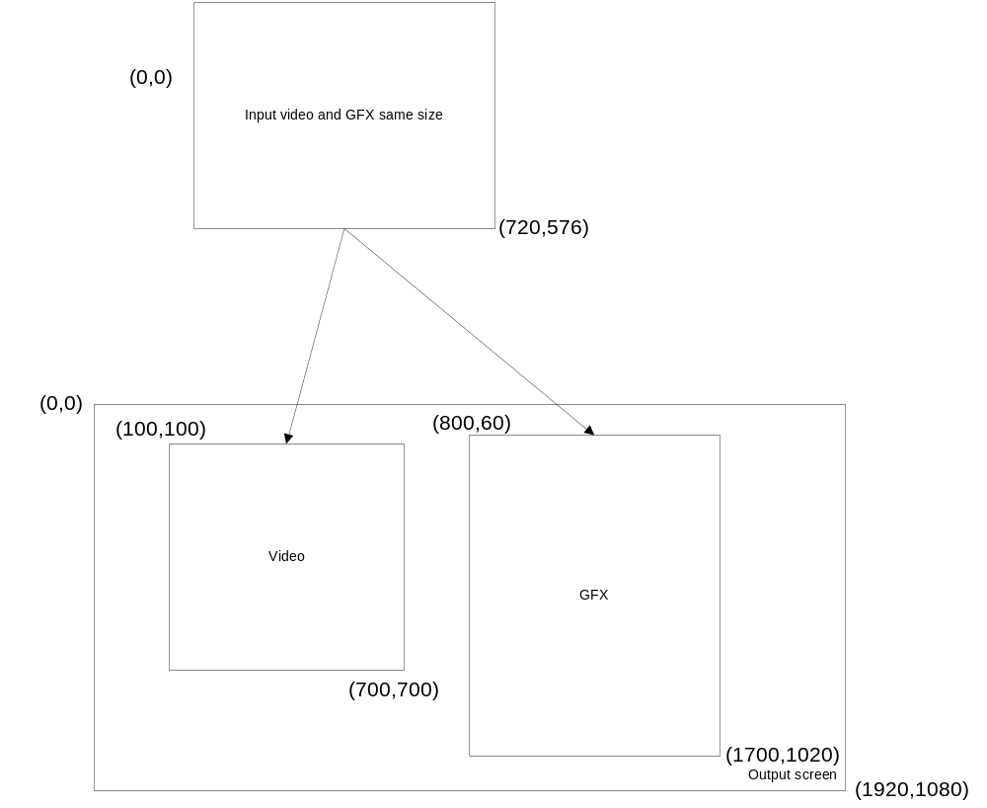
Then TDAL_DISP_BlenderDimensionsOutputSet is called with :
Left=0, Top= -180, Right=1919, Bottom=1259

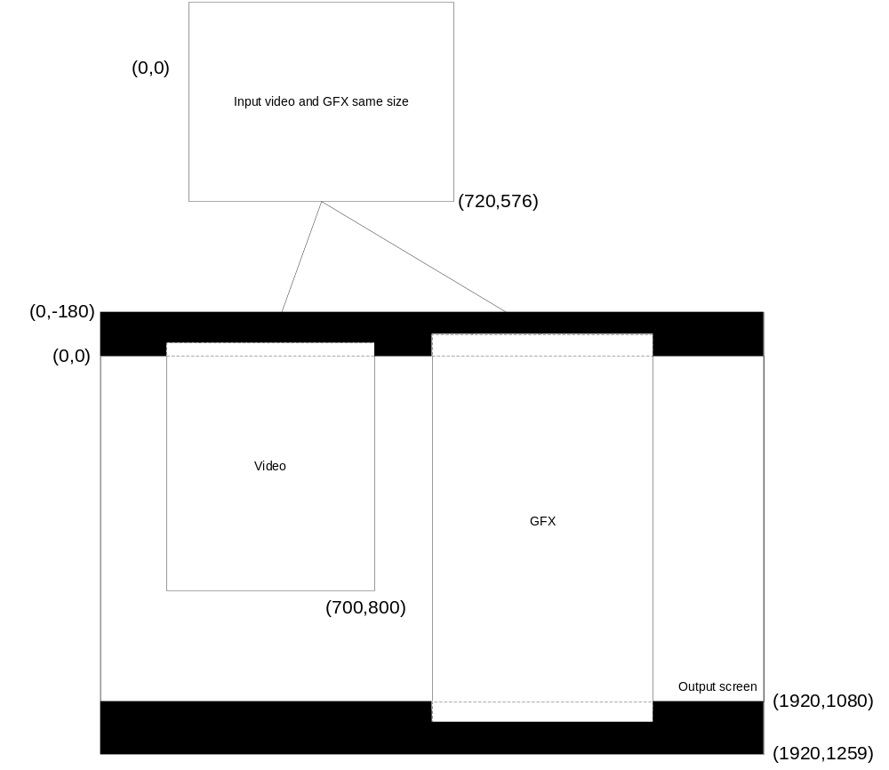
Here the 180 first lines and the 180 last lines of the video are not displayed.
So the actual (vertical) scaling factor is: (1080 + 180*2) / 1080 = 1440/1080 = 1.333 .

For Video :
Starting from the output given by TDAL_DISP_LayerIOWindowSet(), the call to TDAL_DISP_BlenderDimensionsOutputSet() gives :
The y =100 coordinate becomes: 100 * 1.333 = 133.33. So the newTopY = 133.33 - 180 = - 47 (A part on top of the video is not visible).
New height = 600 * 1.333 = 800.
New BottomY = -47 + 800 = 753.

We have to remove 47 lines on top from the 600 lines.

That means that from the original 576 lines, the number of lines to remove is: 47*576/600 = 45.
Finally, we have to remove 45 lines on top of the video.

For GFX :
Starting from the output given by TDAL_DISP_LayerIOWindowSet(), the call to TDAL_DISP_BlenderDimensionsOutputSet() gives :
The y =60 coordinate becomes: 60 * 1.333 = 80. So the newTopY = 80 - 180 = - 100 (A part on top of the gfx is not visible).
New height = 960 * 1.333 = 1280.
New BottomY = -100 + 1280 = 1180 (A part on bottom of gfx is not visible).

We have to remove 200 lines (100 on top and 100 on bottom) from the 960 lines.

From the original 576 lines, nb lines to remove = (100 * 576)/960 = 60.
Finally, we have to remove 60 lines on top and 60 lines on bottom.

Results :
This is achieved by Set IO window whose coordinates are as below:

 | Input | Output
Video | (left,Top) = (0,45)  (right,bottom) = (720,576) | (left,Top) = (100,0)  (right,bottom) = (700,800)
GFX | (left,Top) = (0,60)  (right,bottom) = (720,516) | (left,Top) = (800,0)  (right,bottom) = (1700,1079)

Use case 2
No changes for TDAL_DISP_LayerIOWindowsSet().
For this use case TDAL_DISP_BlenderDimensionsOutputSet is called with :
Left=0, Top= 180, Right=1919, Bottom=899.

The vertical scaling factor is : (1080 - 180*2)/1080 = 0.666
All Video and GFX are displayed.

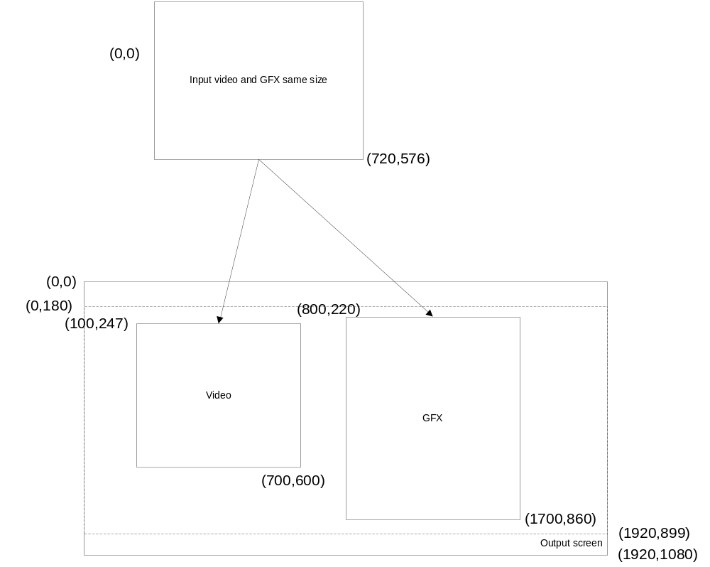
For Video :
Starting from the output given by TDAL_DISP_LayerIOWindowSet(), the call to TDAL_DISP_BlenderDimensionsOutputSet() gives :
The y =100 coordinate becomes: 100 * 0.666 = 66.6 So the newTopY = 66.6 + 180 = 247.
New height = 600* 0.666 = 400.
New BottomY = 400 + 247 = 647.

For GFX :
Starting from the output given by TDAL_DISP_LayerIOWindowSet(), the call to TDAL_DISP_BlenderDimensionsOutputSet() gives :
The y = 60 coordinate becomes: 60 * 0.666 = 40. So the newTopY = 40 + 180 = 220.
New height = 960 * 0.666 = 640.
New BottomY = 640 + 220 = 860.

Results :
This is achieved by Set IO window whose coordinates are as below:

 | Input | Output
Video | (left,Top) = (0,0)  (right,bottom) = (720,576) | (left,Top) = (100,247)  (right,bottom) = (700,647)
GFX | left,Top) = (0,0)  (right,bottom) = (720,756) | (left,Top) = (800,220)  (right,bottom) = (1700,860)

Sample values for the blender
Here are some values used by comedia :

/* Take 14/9 Letter Box Center from input and display Full Screen with Tight black bar Left and Right */
sLeft = 120
sTop = -90
uiRight = 1799
uiBottom = 1169

/* Take 16/9 Letter Box Center from 4/3 and display Full Screen */
sLeft = 0;
sTop = - 180;
uiRight = 1919;
uiBottom = 1259;

/* 4/3 input Pillar Boxed on 16/9 Display */
sLeft = 240;
sTop = 0;
uiRight = 1679;
uiBottom = 1079;

/* Display 14/9 part from 16/9 and display Full Screen*/
sLeft = - 137;
sTop = - 77;
uiRight = 2056;
uiBottom = 1156;

/* Take 14/9 Letter Box Center from 4/3 input and display Full Screen */
sLeft = 0;
sTop = - 90;
uiRight = 1919;
uiBottom = 1169;

/* stretched 14/9 part from 16/9 input and display Full Screen */
sLeft = -137;
sTop = 0;
uiRight = 2056;
uiBottom = 1080;

Interactions with other TDAL modules
TDAL_AV needs an access to the layers to indicate in which video layers, the video decoding result must be sent.
TDAL_GFX needs an access to the layers to indicate in which graphics layers a region is created.
For that purpose and to have a complete independence between the TDAL_DISP, TDAL_AV, TDAL_GFX and other TDAL APIs, the notion of layer handle is used. The layer handle is an unique opaque value that is used as accessor to a specific layer. This handle is used transversely between the different TDAL modules in order to authorize a TDAL module to access the low level driver that manages the layers.

Architecture
The figure below shows the relation between the client module and the low level drivers:
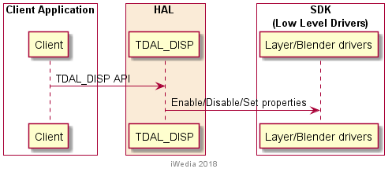

TDAL_DISP API Description

Generic Interface
The generic interface allows clients to control the TDAL_DISP module.
This interface is used with the following functions:
- TDAL_DISP_Init(-) in order to initialize the TDAL_DISP module.
- TDAL_DISP_Term(-) in order to terminate the TDAL_DISP module.
- TDAL_DISP_CapabilityGet(-) in order to get the capabilities of the current implementation of TDAL_DISP module.

Blender Interface
The Blender interface part of the TDAL_DISP API allows clients to control the blenders.
This interface is used with the following functions:
- TDAL_DISP_BlenderCapabilityGet(-) in order to retrieve the capabilities of each available blender.
- TDAL_DISP_BlenderBackgroundColorSet(-) in order to set a background colour on a blender.
- TDAL_DISP_BlenderDimensionsGet(-) in order to get the current dimensions of a blender.
- TDAL_DISP_BlenderDimensionsSet(-) in order to set the dimensions of a blender.
- TDAL_DISP_BlenderDisable(-) in order to disable a blender.
- TDAL_DISP_BlenderEnable(-) in order to enable a blender.
- TDAL_DISP_BlenderZOrderPositionsGet(-) in order to get the possible Z-order positions of the layers in a blender.
- TDAL_DISP_BlenderZOrderListSet(-) in order to set the Z-order list of layers in a blender.
- TDAL_DISP_BlenderDimensionsOutputSet(-) in order to set blender coordinates

Layer Interface
The Layer interface part of the TDAL_DISP API allows clients to control the layers.
This interface is used with the following functions:
- TDAL_DISP_LayerCapabilityGet(-) in order to retrieve the capabilities of each available layer.
- TDAL_DISP_LayerGlobalTransparencySet(-) in order to set global transparency value of a layer.
- TDAL_DISP_LayerHandleGet(-) in order to get an opaque unique handle on a layer.
- TDAL_DISP_LayerIOWindowsAdjust(-) in order to adjust the input/output windows of a layer.
- TDAL_DISP_LayerIOWindowsAspectRatioParamsSet(-) in order to set the aspect ratio input information and the conversion mode of the input/output windows of a layer.
- TDAL_DISP_LayerIOWindowsGet(-) in order to retrieve the current input/output windows of a layer.
- TDAL_DISP_LayerIOWindowsSet(-) in order to set the input/output windows of a layer.
- TDAL_DISP_LayerDisable(-) in order to disable a layer.
- TDAL_DISP_LayerEnable(-) in order to enable a layer.

TDAL_DISP API Specification

Type Specifications

Generic
tTDAL_DISP_Capability is defined to get the capabilities of an implementation of TDAL_DISP.

Blender
The blender identifier tTDAL_DISP_BlenderId is the way used by an application to access in a single way a specific blender in the list of available blenders.

tTDAL_DISP_BlenderCapability is defined to get the capabilities of a blender.

tTDAL_DISP_BlenderZOrderPositions is the way used by an application to access the possible positions that a layer can take in a blender Z-order list.

tTDAL_DISP_BlenderBackgroundColor is defined to set the colour of a blender background.

Layer
The layer identifier tTDAL_DISP_LayerId is the way used by an application to access in a single way a specific layer in the list of available layers. The layer identifier itself holds its own type (video, graphics, still-picture, cursor).

tTDAL_DISP_LayerCapability is defined to get the capabilities of a layer.

tTDAL_DISP_LayerWindow is defined to adjust/get/set the input and output windows of a layer.

TDAL_DISP API Usage

Blender Background colour set
The initialisation of TDAL_DISP API is made. The capability of TDAL_DISP is retrieved to get the number of available blenders. The capability of a blender is retrieved to know the background possibilities (background available or not and colour format). To finish the background colour is set.

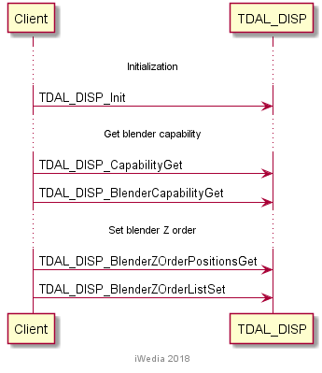

Blender Z-order list set
The initialisation of TDAL_DISP API is made. The capability of TDAL_DISP is retrieved to get the number of available blenders. The capability of a blender is retrieved to know the layer depth in Z-order list. The possible layer positions are retrieved. To finish the Z-order list of layers is set.

Layer input/output windows set
The initialisation of TDAL_DISP API is made. The capability of TDAL_DISP is retrieved to get the number of available blenders. The capability of a blender is retrieved to know the layer depth in Z-order list. The possible layer positions are retrieved to check the availability of a video layer. The current input/output windows of video layer are retrieved. The capability of the video layer is retrieved in order to know the possibility of input and output windowing. The new input/output windows are adjusted and then set.

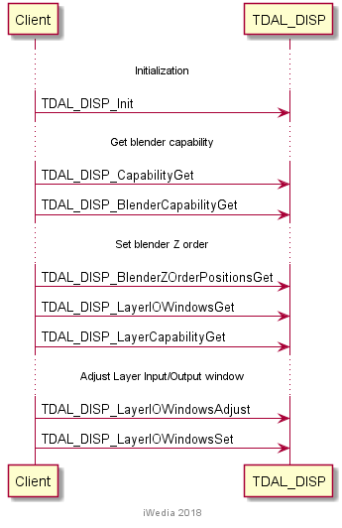

TDAL_DISP Macro/Define/Enum/Typedef/Structure Definitions

Define Definitions

kTDAL_DISP_BLENDER_ZORDER_LIST_ENTRY_NULL
This constant is used to define a special value of blender z-order list entry. It is used to indicate that an entry in the list must be ignored.
#define kTDAL_DISP_BLENDER_ZORDER_LIST_ENTRY_NULL (-1)
Note:
When used, this special value allows to ignore the positions in the z-order list entries where layers have hardware fixed positions.

kTDAL_DISP_BLENDER_ZORDER_LIST_ENTRY_REMOVE
This constant is used to define a special value of blender z-order list entry. It is used to indicate that an entry in the list must be removed from a blender.
#define kTDAL_DISP_BLENDER_ZORDER_LIST_ENTRY_REMOVE (-2)

kTDAL_DISP_PIXEL_FORMAT_CLUT8
This constant is used to define pixel data encoded in clut8.
#define kTDAL_DISP_PIXEL_FORMAT_CLUT8 0x00000001
Note:
In a 32 bit integer, the pixel is mapped as follow:
Bits | Map
[31..24] | unused
[23..16] | unused
[15..8] | unused
[7..0] | index in clut

kTDAL_DISP_PIXEL_FORMAT_ARGB8888
This constant is used to define pixel data encoded in 32 bit with 8 bit for Alpha, Red, Green and Blue components.
#define kTDAL_DISP_PIXEL_FORMAT_ARGB8888 0x00000002
Note:
In a 32 bit integer, the pixel is mapped as follow:
Bits | Map
[31..24] | Alpha
[23..16] | Red
[15..8] | Green
[7..0] | Blue

kTDAL_DISP_PIXEL_FORMAT_AYUV8888
This constant is used to define pixel data encoded in 32 bit with 8 bit for Alpha, Luminance (Y), Chrominance (U-V) components.
#define kTDAL_DISP_PIXEL_FORMAT_AYUV8888 0x00000004
Note:
In a 32 bit integer, the pixel is mapped as follow:
Bits | Map
[31..24] | Alpha
[23..16] | Y
[15..8] | U
[7..0] | V

kTDAL_DISP_PIXEL_FORMAT_RGB888
This constant is used to define pixel data encoded in 24 bit with 8 bit for Red, Green and Blue components.
#define kTDAL_DISP_PIXEL_FORMAT_RGB888 0x00000008
Note:
In a 32 bit integer, the pixel is mapped as follow:
Bits | Map
[31..24] | Red
[23..16] | Green
[15..8] | Blue
[7..0] | unused

kTDAL_DISP_PIXEL_FORMAT_YUV888_444
This constant is used to define pixel data encoded in 24 bit with 8 bit for Luminance (Y), Chrominance (U-V) components.
#define kTDAL_DISP_PIXEL_FORMAT_YUV888_444 0x00000010
Note:
In a 32 bit integer, the pixel is mapped as follow:
Bits | Map
[31..24] | Y
[23..16] | U
[15..8] | V
[7..0] | unused

kTDAL_DISP_PIXEL_FORMAT_YUV888_422
This constant is used to define 2 pixels data encoded in 32 bit with 8 bit for Luminance (Y), Chrominance (U-V) components.
#define kTDAL_DISP_PIXEL_FORMAT_YUV888_422 0x00000020
Note:
In a 32 bit integer, the pixel is mapped as follow:
Bits | Map
[31..24] | Y of 2nd pixel
[23..16] | U
[15..8] | Y of 1st pixel
[7..0] | V

kTDAL_DISP_PIXEL_FORMAT_ARGB4444
This constant is used to define pixel data encoded in 16 bit with 4 bit for Red, Green and Blue components.
#define kTDAL_DISP_PIXEL_FORMAT_ARGB4444 0x00000040
Note:
In a 32 bit integer, the pixel is mapped as follow:
Bits | Map
[31..24] | Unused
[23..16] | Unused
[15..12] | Alpha
[11..8] | Red
[7..4] | Green
[3..0] | Blue

kTDAL_DISP_PIXEL_FORMAT_RGB565
This constant is used to define pixel data encoded in 16 bit with 5 bit for red and blue components and 6 bit for green component.
#define kTDAL_DISP_PIXEL_FORMAT_RGB565 0x00000040
Note:
In a 32 bit integer, the pixel is mapped as follow:
Bits | Map
[31..24] | Unused
[23..16] | Unused
[15..11] | Red
[10..5] | Green
[4..0] | Blue

Enum Definitions

tTDAL_DISP_AspectRatio
An enumeration of the different possible aspect ratio handled by TDAL_DISP.
typedef enum
{
eTDAL_DISP_ASPECT_RATIO_4_3, /* 4/3 aspect ratio */
eTDAL_DISP_ASPECT_RATIO_16_9, /* 16/9 aspect ratio */
eTDAL_DISP_ASPECT_RATIO_221_1, /* 22.1/1 aspect ratio */
eTDAL_DISP_ASPECT_RATIO_1_1, /* 1/1 aspect ratio */
}tTDAL_DISP_AspectRatio;

tTDAL_DISP_AspectRatioConv
An enumeration of the different possible aspect ratio conversion mode handled by TDAL_DISP.
typedef enum
{
eTDAL_DISP_ASPECT_RATIO_CONV_FULL_SCREEN, /* Full screen conv. */
eTDAL_DISP_ASPECT_RATIO_CONV_16_9_LETTER_BOX, /* 16/9 letter box conv. */
eTDAL_DISP_ASPECT_RATIO_CONV_14_9_LETTER_BOX, /* 14/9 letter box conv. */
eTDAL_DISP_ASPECT_RATIO_CONV_4_3_CENTER_CUT_OUT, /* 4/3 center cut out conv. */
eTDAL_DISP_ASPECT_RATIO_CONV_4_3_PILLAR_BOX, /* 4/3 pillar box conv. */
eTDAL_DISP_ASPECT_RATIO_CONV_IGNORE, /* No aspect ratio conv.*/
}tTDAL_DISP_AspectRatioConv;
Full screen:
This mode is used with SD 16:9 display configuration. 16:9 video will be displayed full screen, and 4:3 video will be handled by the TV set.
This mode is used also with HD 16:9 display configuration. 16:9 video will be displayed full screen, and 4:3 video will be stretched to full screen.
16/9 Letter box:
This mode is used with SD 4:3 display configuration. 16:9 video will be displayed full width with bars at the top and bottom, and 4:3 video will be displayed full screen.
14/9 Letter box:
This mode is used with SD 4:3 display configuration. 16:9 video will be displayed with small bars at the top and bottom, and with the left and right slightly cut, and 4:3 video will be displayed full screen.
4/3 Center Cut Out:
This mode is used with SD 4:3 display configuration. 16:9 video will be displayed with the left and right cut, and 4:3 video will be displayed full screen.
This mode is also used with HD 16:9 display configuration. 16:9 video will be displayed full screen, and 4:3 video will be displayed full height with the top and bottom cut.
4/3 Pillar box:
This mode is used with HD 16:9 display configuration. 16:9 video will be displayed full screen, and 4:3 video will be displayed with bars at the left and right.

tTDAL_DISP_Error
An enumeration of the different possible errors generated by TDAL_DISP module.
typedef enum
{
eTDAL_DISP_NO_ERROR, /* No Error returned */
eTDAL_DISP_NOT_INIT_ERROR, /* TDAL_DISP has been initialised */
eTDAL_DISP_ALREADY_INIT_ERROR, /* TDAL_DISP already initialised */
eTDAL_DISP_BAD_PARAMETER_ERROR, /* Bad parameter given to the function */
eTDAL_DISP_DRIVER_ERROR, /* Low level driver returns an error */
eTDAL_DISP_NO_MEMORY_ERROR, /* Not enough memory to perform action */
eTDAL_DISP_NOT_AVAILABLE_ERROR, /* feature not available */
}tTDAL_DISP_Error;

tTDAL_DISP_BlenderId
An enumeration of the blender identifiers supported by TDAL_DISP module.
typedef enum
{
eTDAL_DISP_BLENDER_ID_0, /* Blender identifier 0 */
eTDAL_DISP_BLENDER_ID_1, /* Blender identifier 1 */
eTDAL_DISP_BLENDER_ID_2, /* Blender identifier 2 */
eTDAL_DISP_BLENDER_ID_3, /* Blender identifier 3 */
}tTDAL_DISP_BlenderId;

tTDAL_DISP_LayerId
An enumeration of the layer identifiers supported by TDAL_DISP module.
typedef enum
{
eTDAL_DISP_LAYER_VIDEO_ID_0, /* Layer video identifier 0 */
eTDAL_DISP_LAYER_VIDEO_ID_1, /* Layer video identifier 1 */
eTDAL_DISP_LAYER_VIDEO_ID_2, /* Layer video identifier 2 */
eTDAL_DISP_LAYER_GFX_ID_0, /* Layer graphics identifier 0 */
eTDAL_DISP_LAYER_GFX_ID_1, /* Layer graphics identifier 1 */
eTDAL_DISP_LAYER_GFX_ID_2, /* Layer graphics identifier 2 */
..eTDAL_DISP_LAYER_STILL_ID_0, /* Layer still-picture identifier 0 */
..eTDAL_DISP_LAYER_STILL_ID_1, /* Layer still-picture identifier 1 */
..eTDAL_DISP_LAYER_CURSOR_ID_0, /* Layer cursor identifier 0 */
..eTDAL_DISP_LAYER_CURSOR_ID_1, /* Layer cursor identifier 1 */
}tTDAL_DISP_LayerId;

Typedef Definitions
None.

Structure Definitions

tTDAL_DISP_Capability
Description:
This structure defines the supported features of a given implementation of TDAL_DISP module.
Definition:
typedef struct
{
uint8_t nbBlender;
}tTDAL_DISP_Capability;
Elements:
Field | Type | Description
nbBlender | uint8_t | Number of different blenders that can be controlled.
Comments:
The different blenders are identified with the tTDAL_DISP_BlenderId enumeration values.
For example, if there are 2 only different blenders in the system, eTDAL_DISP_BLENDER_ID_0 and eTDAL_DISP_BLENDER_ID_1 can be used in the TDAL_DISP_BlenderXXX(-) functions otherwise eTDAL_DISP_NOT_AVAILABLE_ERROR is returned.
See Also:
tTDAL_DISP_BlenderId.
TDAL_DISP_CapabilityGet(-).

tTDAL_DISP_BlenderCapability
Description:
This structure defines the supported features of a given blender of TDAL_DISP module.
Definition:
typedef struct
{
uint16_t widthMax;
..uint16_t heightMax;
bool bBackgroundColor;
uint32_t backgroundColorPixelFormatMask;
uint8_t nbLayer;
}tTDAL_DISP_BlenderCapability;
Elements:
Field | Type | Description
widthMax | uint16_t | Maximum width (in pixels) of the blender layer disposal.
heightMax | uint16_t | Maximum height (in lines) of the blender layer disposal.
bBackgroundColor | bool | FALSE: no background colour supported on this blender.  TRUE: background colour supported.
backgroundColorPixelFormatMask | uint32_t | Bitfield where pixel formats are set to indicate the supported background pixel format.  This field is only relevant if bBackgroundColor is TRUE.
nbLayer | uint8_t | Number of different layers which can be added in the z-order list of this blender.
Comments:
None.
See Also:
TDAL_DISP_BlenderCapabilityGet(-).

tTDAL_DISP_BlenderZOrderPositions
Description:
This structure is used to retrieve the positions that a layer can take in the z-order list of a blender.
Definition:
typedef struct
{
tTDAL_DISP_LayerId LayerId;
uint32_t ZOrderPositions
} tTDAL_DISP_BlenderZOrderPositions;
Elements:
Field | Type | Description
LayerId | tTDAL_DISP_LayerId | Layer identifier.
ZOrderPositions | uint32_t | Bitmask where each bit set to 1 indicates where the layer can be positioned in the z-order list.
Comments:
For example, if zOrderPositions = 0x32 (00110010b) then the layer can be positioned in the z-order list at index 1, 4 and 5.
See Also:
tTDAL_DISP_LayerId.
TDAL_DISP_BlenderZOrderPositionsGet(-).

tTDAL_DISP_BlenderBackgroundColor
Description:
This structure is to define a background colour for a blender.
Definition:
typedef struct
{
uint32_t PixelFormat;
..uint32_t Color;
}tTDAL_DISP_BlenderBackgroundColor;
Elements:
Field | Type | Description
PixelFormat | uint32_t | The pixel colour format coded in Color field. It is one of kTDAL_DISP_PIXEL_FORMAT_XXX indicated in the backgoundColorPixelFormatMask field of the blender capabilities.
Color | uint32_t | The background colour value coded with the format indicated in the PixelFormat field. See kTDAL_DISP_PIXEL_FORMAT_XXX description of the pixel mapping in a 32 bit integer.
Comments:
None.
See Also:
TDAL_DISP_BlenderBackgroundColorSet(-).

tTDAL_DISP_BlenderWindow
Description:
This structure is to define a blender coordinated on screen.
Definition:
typedef struct
{
int32_t sLeft;
int32_t sTop;
uint32_t uiRight;
uint32_t uiBottom;
} tTDAL_DISP_BlenderWindow;
Elements:
Field | Type | Description
sLeft | int32_t | Left coordinates (could be negativ)
sTop | int32_t | Top coordinates (could be negativ)
uiRight | uint32_t | Right coordinates
uiBottom | uint32_t | Bottom coordinates
Comments:
None.
See Also:

tTDAL_DISP_LayerCapability
Description:
This structure defines the supported features of a given layer of TDAL_DISP module.
Definition:
typedef struct
{
int32_t NbRegionMax;
..bool IsMultiRegionOnSameLineCapable;
..bool IsInputWindowCapable;
bool IsOutputWindowCapable;
bool IsGlobalTransparencyCapable;
bool IsAspectRatioWindowConvCapable;
}tTDAL_DISP_LayerCapability;
Elements:
Field | Type | Description
NbRegionMax | uint32_t | Maximum number of regions that the layer is able to display. If the number is unknown or is only limited by memory amount available in the system, (-1) is indicated.
IsMultiRegionOnSameLineCapable | bool | It is only relevant if NbRegionMax > 1. TRUE if the layer is able to display more than one region in a same line. FALSE otherwise.
IsInputWindowCapable | bool | TRUE if input windowing is supported by the layer. FALSE otherwise.
IsOutputWindowCapable | bool | TRUE if output windowing is supported by the layer. FALSE otherwise.
IsGlobalTransparencyCapable | bool | TRUE if the layer is able to perform a global transparency.
IsAspectRatioWindowConvCapable | bool | TRUE if TDAL_DISP implementation is capable of resizing output window upon input window aspect ratio information (see 4.2.2.1 for more details). In this case, the TDAL_DISP client is allowed to call TDAL_DISP_LayerIOWindowsAspectRatioParamsSet(-).
Comments:
None.
See Also:
TDAL_DISP_LayerCapabilityGet(-).

tTDAL_DISP_LayerWindow
Description:
This structure defines a geometric rectangle in position and size. The position is the top left pixel of the rectangle.
Definition:
typedef struct
{
uint32_t Left;
uint32_t Top;
uint32_t Right;
uint32_t Bottom;
} tTDAL_DISP_LayerWindow;
Elements:
Field | Type | Description
Left | uint32_t | Left position of the window rectangle (in pixels).
Top | uint32_t | Top position of the window rectangle (in lines).
Right | uint32_t | Right position of the window rectangle (in pixels).
Bottom | uint32_t | Bottom position of the window rectangle (in lines).
Comments:
None.
See Also:
TDAL_DISP_LayerIOWindowsAdjust(-).
TDAL_DISP_LayerIOWindowsGet(-).
TDAL_DISP_LayerIOWindowsSet(-).

TDAL_DISP API Functions

Generic Interface API

TDAL_DISP_Init(-)
Prototype:
tTDAL_DISP_Error TDAL_DISP_Init (void);
Description:
This function initialises the TDAL_DISP module.
Return value:
It returns eTDAL_DISP_NO_ERROR if initialization succeed.
It could eTDAL_DISP_DRIVER_ERROR, eTDAL_DISP_ALREADY_INIT_ERROR or eTDAL_DISP_NO_MEMORY_ERROR otherwise.
Parameters:
None.
Comments:
This function must be called before any other functions of the TDAL_DISP API.
See Also:
TDAL_DISP_Term(-).

TDAL_DISP_Term(-)
Prototype:
tTDAL_DISP_Error TDAL_DISP_Term (void);
Description:
This function terminates the TDAL_DISP module.
Return value:
It returns eTDAL_DISP_NO_ERROR if termination succeed.
It could be eTDAL_DISP_DRIVER_ERROR, eTDAL_DISP_NOT_INIT_ERROR otherwise.
Parameters:
None.
Comments:
Any function of TDAL_DISP API should not be called after TDAL_DISP_Term(-) call.
See Also:
TDAL_DISP_Init(-).

TDAL_DISP_CapabilityGet(-)
Prototype:
tTDAL_DISP_Error TDAL_DISP_CapabilityGet
(
tTDAL_DISP_Capability *pstCapability
);
Description:
This function retrieves the capabilities of the TDAL_DISP current implementation.
Return value:
It returns eTDAL_DISP_NO_ERROR if retrieve of capabilities succeed. It could be eTDAL_DISP_NOT_INIT_ERROR, eTDAL_DISP_DRIVER_ERROR, eTDAL_DISP_BAD_PARAMETER_ERROR or eTDAL_DISP_NO_MEMORY_ERROR otherwise.
Parameters:
Parameter | Type | Dir | Description
pstCapability | tTDAL_DISP_Capability * | In/out | In: Allocated capability structure pointer.  Out: Structure filled with capabilities of the implementation of the TDAL_DISP module.
Comments:
This function can be called at any time the TDAL_DISP has been initialised with TDAL_DISP_Init(-) but not after the termination with TDAL_DISP_Term(-).
See Also:
tTDAL_DISP_Capability

TDAL_DISP_APIRevisionGet(-)
Prototype:
Cont char *TDAL_DISP_APIRevisionGet(void);
Description:
This function retrieves the API revision.
Return value:
A string containing the revision of the TDAL_DISP API.
Parameters:
None.
Comments:
This function can be called at any time.
See Also:

TDAL_DISP_PlatformRevisionGet(-)
Prototype:
Const char *TDAL_DSIP_PlatformRevisionGet(void);
Description:
This function retrieves the platform implementation revision.
Return value:
A string containing the revision of the TDAL_DISP implementation on a platform.
Parameters:
None.
Comments:
This function can be called at any time.
See Also:

Blender Interface API

TDAL_DISP_BlenderCapabilityGet(-)
Prototype:
tTDAL_DISP_Error TDAL_DISP_BlenderCapabilityGet
(
tTDAL_DISP_BlenderId Id,
tTDAL_DISP_BlenderCapability *pstCapability
);
Description:
This function retrieves the capabilities of the defined TDAL_DISP blender.
Return value:
It returns eTDAL_DISP_NO_ERROR if retrieve of capabilities succeed. It could be eTDAL_DISP_NOT_INIT_ERROR, eTDAL_DISP_DRIVER_ERROR, eTDAL_DISP_BAD_PARAMETER_ERROR or eTDAL_DISP_NO_MEMORY_ERROR otherwise.
If blender identifier is not supported, eTDAL_DISP_NOT_AVAILABLE_ERROR is returned.
Parameters:
Parameter | Type | Dir | Description
Id | tTDAL_DISP_BlenderId | In | Blender identifier.
pstCapability | tTDAL_DISP_BlenderCapability * | In/Out | In: Allocated capability structure pointer.  Out: Structure filled with blender capabilities of the implementation of the TDAL_DISP module.
Comments:
To know the number of available blender(s), TDAL_DISP_CapabilityGet(-) must be called first.
This function can be called at any time the TDAL_DISP has been initialised with TDAL_DISP_Init(-) but not after the termination with TDAL_DISP_Term(-).
See Also:
tTDAL_DISP_BlenderId.
tTDAL_DISP_BlenderCapability.

TDAL_DISP_BlenderBackgroundColorSet(-)
Prototype:
tTDAL_DISP_Error TDAL_DISP_BlenderBackgroundColorSet
(
tTDAL_DISP_BlenderId Id,
tTDAL_DISP_BlenderBackgroundColor *pstColor
);
Description:
This function sets the background colour of the blender.
Return value:
It returns eTDAL_DISP_NO_ERROR if background colour set succeed. It could be eTDAL_DISP_DRIVER_ERROR, eTDAL_DISP_BAD_PARAMETER_ERROR otherwise.
If blender identifier is not supported, eTDAL_DISP_NOT_AVAILABLE_ERROR is returned.
Parameters:
Parameter | Type | Dir | Description
Id | tTDAL_DISP_BlenderId | In | Blender identifier
pstColor | tTDAL_DISP_BlenderBackgroundColor * | In | Pointer to an allocated background colour structure.
Comments:
The background colour feature possibility (background supported or not, colour pixel formats supported) can be retrieved with TDAL_DISP_BlenderCapabilityGet(-).
The blender disposal dimensions must have been set with TDAL_DISP_BlenderDimensionsGet(-).
See Also:
tTDAL_DISP_BlenderId.
tTDAL_DISP_BlenderBackgroundColor.

TDAL_DISP_BlenderDimensionsGet(-)
Prototype:
tTDAL_DISP_Error TDAL_DISP_BlenderDimensionsGet
(
tTDAL_DISP_BlenderId Id,
uint32_t *pWidth,
uint32_t *pHeight
);
Description:
This function gets the current dimensions of the disposal of the blender.
Return value:
It returns eTDAL_DISP_NO_ERROR if disposal dimension set succeed. It could be eTDAL_DISP_DRIVER_ERROR, eTDAL_DISP_BAD_PARAMETER_ERROR otherwise.
If blender identifier is not supported, eTDAL_DISP_NOT_AVAILABLE_ERROR is returned.
Parameters:
Parameter | Type | Dir | Description
Id | tTDAL_DISP_BlenderId | In | Blender identifier
pWidth | uint32_t * | In/Out | In: Pointer to an allocated width.  Out: Width (in pixels) of the disposal of the blender.
Height | uint32_t | In/Out | In: Pointer to an allocated height.  Out: Height (in lines) of the disposal of the blender.
Comments:
None.
See Also:
tTDAL_DISP_BlenderId.
TDAL_DISP_BlenderDimensionsSet(-).

TDAL_DISP_BlenderDimensionsSet(-)
Prototype:
tTDAL_DISP_Error TDAL_DISP_BlenderDimensionsSet
(
tTDAL_DISP_BlenderId Id,
uint32_t Width,
uint32_t Height
);
Description:
This function sets the dimensions of the disposal of the blender.
Return value:
It returns eTDAL_DISP_NO_ERROR if disposal dimension set succeed. It could be eTDAL_DISP_DRIVER_ERROR, eTDAL_DISP_BAD_PARAMETER_ERROR otherwise.
If blender identifier is not supported, eTDAL_DISP_NOT_AVAILABLE_ERROR is returned.
Parameters:
Parameter | Type | Dir | Description
Id | tTDAL_DISP_BlenderId | In | Blender identifier
Width | uint32_t | In | Width (in pixels) of the disposal of the blender that must be greater than 0.
Height | uint32_t | In | Height (in lines) of the disposal of the blender that must be greater than 0.
Comments:
The maximum values of the dimensions can be retrieved with TDAL_DISP_BlenderCapabilityGet(-).
The width and height values have to be in adequacy with the video standard used on video outputs.
See Also:
tTDAL_DISP_BlenderId.
TDAL_DISP_BlenderDimensionsGet(-).

TDAL_DISP_BlenderDisable(-)
Prototype:
tTDAL_DISP_Error TDAL_DISP_BlenderDisable
(
tTDAL_DISP_BlenderId Id
);
Description:
This function disables the blender.
Return value:
It returns eTDAL_DISP_NO_ERROR if disable succeed. It could be eTDAL_DISP_DRIVER_ERROR, eTDAL_DISP_BAD_PARAMETER_ERROR otherwise.
If blender identifier is not supported, eTDAL_DISP_NOT_AVAILABLE_ERROR is returned.
Parameters:
Parameter | Type | Dir | Description
Id | tTDAL_DISP_BlenderId | In | Blender identifier
Comments:
None.
See Also:
tTDAL_DISP_BlenderId.

TDAL_DISP_BlenderEnable(-)
Prototype:
tTDAL_DISP_Error TDAL_DISP_BlenderEnable
(
tTDAL_DISP_BlenderId Id
);
Description:
This function enables the blender.
Return value:
It returns eTDAL_DISP_NO_ERROR if enable succeed. It could be eTDAL_DISP_DRIVER_ERROR, eTDAL_DISP_BAD_PARAMETER_ERROR otherwise.
If blender identifier is not supported, eTDAL_DISP_NOT_AVAILABLE_ERROR is returned.
Parameters:
Parameter | Type | Dir | Description
Id | tTDAL_DISP_BlenderId | In | Blender identifier
Comments:
None.
See Also:
tTDAL_DISP_BlenderId.

TDAL_DISP_BlenderZOrderPositionsGet(-)
Prototype:
tTDAL_DISP_Error TDAL_DISP_BlenderZOrderPositionsGet
(
tTDAL_DISP_BlenderId Id,
tTDAL_DISP_BlenderZOrderPositions *pstZOrderList
);
Description:
This function retrieves the possible positions in the blender z-order list that each layer can take.
Return value:
It returns eTDAL_DISP_NO_ERROR if retrieve of succeed. It could be eTDAL_DISP_DRIVER_ERROR, eTDAL_DISP_BAD_PARAMETER_ERROR or eTDAL_DISP_NO_MEMORY_ERROR otherwise.
If blender identifier is not supported, eTDAL_DISP_NOT_AVAILABLE_ERROR is returned.
Parameters:
Parameter | Type | Dir | Description
Id | tTDAL_DISP_BlenderId | In | Blender identifier
pstZOrderList | tTDAL_DISP_BlenderZOrderPositions * | In/Out | In: Allocated array of structures. The size of the array corresponds to nbLayer field value of the tTDAL_DISP_BlenderCapability.  Out: Array structure filled with the possible positions each layer can take.
Comments:
This function can be called at any time the TDAL_DISP has been initialised with TDAL_DISP_Init(-) but not after the termination with TDAL_DISP_Term(-).
Typically, this function can be used to know the list of available layer identifiers supported by TDAL_DISP module implementation.
See Also:
tTDAL_DISP_BlenderId.
tTDAL_DISP_BlenderZOrderPositions.

TDAL_DISP_BlenderZOrderListSet(-)
Prototype:
tTDAL_DISP_Error TDAL_DISP_BlenderZOrderListSet
(
tTDAL_DISP_BlenderId Id,
tTDAL_DISP_LayerId *pstZOrderList
);
Description:
This function set the layer positions in the blender z-order list.
Return value:
It returns eTDAL_DISP_NO_ERROR if retrieve of succeed. It could be eTDAL_DISP_DRIVER_ERROR, eTDAL_DISP_BAD_PARAMETER_ERROR otherwise.
If blender identifier is not supported, eTDAL_DISP_NOT_AVAILABLE_ERROR is returned.
Parameters:
Parameter | Type | Dir | Description
Id | tTDAL_DISP_BlenderId | In | Blender identifier
pstZOrderList | tTDAL_DISP_LayerId * | In | Allocated array of layer identifiers. The size of the array corresponds to nbLayer field value of the tTDAL_DISP_BlenderCapability.  Each array entry has to be set with a layer identifier or with kTDAL_DISP_BLENDER_ZORDER_LIST_ENTRY_NULL value if the position has to be ignored or with kTDAL_DISP_BLENDER_ZORDER_LIST_ENTRY_REMOVE value if the current connected layer has to be removed from the blender.
Comments:
The z-order list depth of the blender can be retrieved with TDAL_DISP_BlenderCapabilityGet(-).
The blender disposal dimensions must have been set with TDAL_DISP_BlenderDimensionsGet(-).
See Also:
tTDAL_DISP_BlenderId.
tTDAL_DISP_LayerId.

TDAL_DISP_BlenderDimensionsOutputSet (-)
Prototype:
tTDAL_DISP_Error
TDAL_DISP_BlenderDimensionsOutputSet(
tTDAL_DISP_BlenderId Id,
tTDAL_DISP_BlenderWindow *pstOutputWindow
);
Description:
This function set the blender coordinates.
Return value:
It returns eTDAL_DISP_NO_ERROR if retrieve of succeed.
It could be eTDAL_DISP_DRIVER_ERROR, eTDAL_DISP_BAD_PARAMETER_ERROR otherwise.
If blender identifier is not supported, eTDAL_DISP_NOT_AVAILABLE_ERROR is returned.
Parameters:
Parameter | Type | Dir | Description
Id | tTDAL_DISP_BlenderId | In | Blender identifier
pstOutputWindow | tTDAL_DISP_BlenderWindow * | In | New blender coordinates
Comments:

See Also:
tTDAL_DISP_BlenderId.

Layer Interface API

TDAL_DISP_LayerCapabilityGet(-)
Prototype:
tTDAL_DISP_Error TDAL_DISP_LayerCapabilityGet
(
tTDAL_DISP_LayerId Id,
tTDAL_DISP_LayerCapability *pstCapability
);
Description:
This function is used to retrieve the capabilities of each available layer.
Return value:
It returns eTDAL_DISP_NO_ERROR if retrieve of capabilities succeed. It could be eTDAL_DISP_DRIVER_ERROR, eTDAL_DISP_BAD_PARAMETER_ERROR or eTDAL_DISP_NO_MEMORY_ERROR otherwise.
If the layer identifier is not supported by the implementation of TDAL_DISP, eTDAL_DISP_NOT_AVAILABLE_ERROR is returned.
Parameters:
Parameter | Type | Dir | Description
Id | tTDAL_DISP_LayerId | In | Layer identifier
pstCapability | tTDAL_DISP_LayerCapability * | In/Out | In: Allocated capability structure pointer.  Out: Structure filled with layer capabilities of the implementation of the TDAL_DISP module.
Comments:
None.
See Also:
tTDAL_DISP_LayerId.
tTDAL_DISP_BlenderWindow.

TDAL_DISP_LayerGlobalTransparencySet(-)
Prototype:
tTDAL_DISP_Error TDAL_DISP_LayerGlobalTransparencySet
(
tTDAL_DISP_LayerId Id,
uint8_t Transparency
);
Description:
This function is used to set global transparency value of a layer.
Return value:
It returns eTDAL_DISP_NO_ERROR if retrieve of capabilities succeed. It could be eTDAL_DISP_DRIVER_ERROR, eTDAL_DISP_BAD_PARAMETER_ERROR or eTDAL_DISP_NO_MEMORY_ERROR otherwise.
If the layer identifier or if the global transparency for the specified layer are not supported by the implementation of TDAL_DISP eTDAL_DISP_NOT_AVAILABLE_ERROR is returned.
Parameters:
Parameter | Type | Dir | Description
Id | tTDAL_DISP_LayerId | In | Layer identifier.
Transparency | uint8_t | In | Global transparency to be set. 0 means opaque and 255 full transparent.
Comments:
TDAL_DISP_LayerCapabilityGet(-) can be used to know if global transparency is supported by the layer.
See Also:
tTDAL_DISP_LayerId.

TDAL_DISP_LayerHandleGet(-)
Prototype:
tTDAL_DISP_Error TDAL_DISP_LayerHandleGet
(
tTDAL_DISP_LayerId Id,
void *pHandle
);
Description:
This function is used to get an opaque unique handle on a layer.
Return value:
It returns eTDAL_DISP_NO_ERROR if retrieve of capabilities succeed. It could be eTDAL_DISP_DRIVER_ERROR, eTDAL_DISP_BAD_PARAMETER_ERROR or eTDAL_DISP_NO_MEMORY_ERROR otherwise.
In case of the layer identifier is not supported by the implementation of TDAL_DISP, eTDAL_DISP_NOT_AVAILABLE_ERROR is returned.
Parameters:
Parameter | Type | Dir | Description
Id | tTDAL_DISP_LayerId | In | Layer identifier.
pHandle | void * | In/Out | In: pointer to a layer handle  Out: unique layer handle.
Comments:
The opaque handle is typically used in other TDAL modules which needs to link information to a layer (creation of graphics region, destination of a video decode, …). For more details, see chapter 4.2.2.2.
See Also:
tTDAL_DISP_LayerId.

TDAL_DISP_LayerIOWindowsAdjust(-)
Prototype:
tTDAL_DISP_Error TDAL_DISP_LayerIOWindowsAdjust
(
tTDAL_DISP_LayerId Id,
tTDAL_DISP_LayerWindow *pstInputWindow,
tTDAL_DISP_LayerWindow *pstOutputWindow,
bool *pbAdjusted;
);
Description:
This function is used to adjust the input/output windows of a layer.
Return value:
It returns eTDAL_DISP_NO_ERROR if retrieve of capabilities succeed. It could be eTDAL_DISP_DRIVER_ERROR, eTDAL_DISP_BAD_PARAMETER_ERROR or eTDAL_DISP_NO_MEMORY_ERROR otherwise.
In case of the layer identifier is not supported by the implementation of TDAL_DISP, eTDAL_DISP_NOT_AVAILABLE_ERROR is returned.
Parameters:
Parameter | Type | Dir | Description
Id | tTDAL_DISP_LayerId | In | Layer identifier.
pstInputWindow | tTDAL_DISP_LayerWindow | In/Out | In: Input window to be adjusted.  Out: Input window adjusted.
pstOutputWindow | tTDAL_DISP_LayerWindow | In/Out | In: Output window to be adjusted.  Out: Output window adjusted.
pbAdjusted | bool * | In/Out | In: Pointer to a boolean.  Out: TRUE if the input and/or output windows have been adjusted. FALSE if the input and output window have not been adjusted and fit hardware constraints.
Comments:
This function does not change the visual display. It checks the input/output windows against the hardware constraints.
For example, some TDAL_DISP implementation is able only to use discrete values in term of scaling. The adjusted windows must be as near as possible inside the windows to be adjusted.

TDAL_DISP_LayerIOWindowsAspectRatioParamsSet(-)
Prototype:
tTDAL_DISP_Error TDAL_DISP_LayerIOWindowsAspectRatioParamsSet
(
tTDAL_DISP_LayerId Id,
tTDAL_DISP_LayerWindow *pstInputWindow,
tTDAL_DISP_AspectRatio InputAspectRatio,
uint32_t InputAFD,
tTDAL_DISP_AspectRatioConv AspectRatioConv
);
Description:
This function is used to resize the output windows of a layer upon input window size, aspect ratio and AFD information.
Return value:
It returns eTDAL_DISP_NO_ERROR if retrieve of capabilities succeed. It could be eTDAL_DISP_DRIVER_ERROR, eTDAL_DISP_BAD_PARAMETER_ERROR or eTDAL_DISP_NO_MEMORY_ERROR otherwise.
In case of the layer identifier is not supported or output window resize is not implemented, eTDAL_DISP_NOT_AVAILABLE_ERROR is returned.
Parameters:
Parameter | Type | Dir | Description
Id | tTDAL_DISP_LayerId | In | Layer identifier.
pstInputWindow | tTDAL_DISP_LayerWindow | In | Input window size information.
InputAspectRatio | tTDAL_DISP_AspectRatio | In | Input aspect ratio information.
InputAFD | uint32_t | In | Input Active Format Description information.
AspectRatioConv | tTDAL_DISP_AspectRatioConv | In | Pixel aspect ratio conversion to be applied.
Comments:
This function must be implemented if IsAspectRatioWindowConvCapable field is set to TRUE in tTDAL_DISP_BlenderWindow. See chapter 4.2.2.1 for the conditions of implementation.
The call to this function supersedes all the previous input/output window configuration made by TDAL_DISP_LayerIOWindowsSet(-) call. It means that full screen mode in input and output windows are activated.
See Also:
tTDAL_DISP_LayerId.
tTDAL_DISP_LayerWindow.
tTDAL_DISP_AspectRatio.
tTDAL_DISP_AspectRatioConv.

TDAL_DISP_LayerIOWindowsGet(-)
Prototype:
tTDAL_DISP_Error TDAL_DISP_LayerIOWindowsGet
(
tTDAL_DISP_LayerId Id,
tTDAL_DISP_LayerWindow *pstInputWindow,
tTDAL_DISP_LayerWindow *pstOutputWindow,
);
Description:
This function is used in order to retrieve the current input/output windows of a layer.
Return value:
It returns eTDAL_DISP_NO_ERROR if retrieve of capabilities succeed. It could be eTDAL_DISP_DRIVER_ERROR, eTDAL_DISP_BAD_PARAMETER_ERROR or eTDAL_DISP_NO_MEMORY_ERROR otherwise.
In case of the layer identifier is not supported by the implementation of TDAL_DISP, eTDAL_DISP_NOT_AVAILABLE_ERROR is returned.
Parameters:
Parameter | Type | Dir | Description
Id | tTDAL_DISP_LayerId | In | Layer identifier.
pstInputWindow | tTDAL_DISP_LayerWindow | In/Out | In: Pointer to input window.  Out: current input window .
pstOutputWindow | tTDAL_DISP_LayerWindow | In/Out | In: Pointer to output window.  Out: Current output window.
Comments:
None.
See Also:
tTDAL_DISP_LayerId.
tTDAL_DISP_LayerWindow.

TDAL_DISP_LayerIOWindowsSet(-)
Prototype:
tTDAL_DISP_Error TDAL_DISP_LayerIOWindowsSet
(
tTDAL_DISP_LayerId Id,
tTDAL_DISP_LayerWindow *pstInputWindow,
tTDAL_DISP_LayerWindow *pstOutputWindow,
);
Description:
This function is used to set the input/output windows of a layer.
Return value:
It returns eTDAL_DISP_NO_ERROR if retrieve of capabilities succeed. It could eTDAL_DISP_DRIVER_ERROR, eTDAL_DISP_BAD_PARAMETER_ERROR or eTDAL_DISP_NO_MEMORY_ERROR otherwise.
In case of the layer identifier is not supported by the implementation of TDAL_DISP, eTDAL_DISP_NOT_AVAILABLE_ERROR is returned.
Parameters:
Parameter | Type | Dir | Description
Id | tTDAL_DISP_LayerId | In | Layer identifier.
pstInputWindow | tTDAL_DISP_LayerWindow | In | In: Pointer to input window to be set.
pstOutputWindow | tTDAL_DISP_LayerWindow | In | In: Pointer to output window to be set.
Comments:
If the input/output windows to be set have not been adjusted with TDAL_DISP_LayerIOWindowsAdjust(-) function and if they are not compatible with hardware constraints, eTDAL_DISP_BAD_PARAMETER_ERROR is returned.
See Also:
tTDAL_DISP_LayerId.
tTDAL_DISP_LayerWindow.

TDAL_DISP_LayerDisable(-)
Prototype:
tTDAL_DISP_Error TDAL_DISP_LayerDisable
(
tTDAL_DISP_LayerId Id
);
Description:
This function disables the layer.
Return value:
It returns eTDAL_DISP_NO_ERROR if layer disable succeed. It could be eTDAL_DISP_DRIVER_ERROR, eTDAL_DISP_BAD_PARAMETER_ERROR otherwise.
If layer identifier is not supported, eTDAL_DISP_NOT_AVAILABLE_ERROR is returned.
Parameters:
Parameter | Type | Dir | Description
Id | tTDAL_DISP_LayerId | In | Layer identifier
Comments:
None.
See Also:
tTDAL_DISP_LayerId.

TDAL_DISP_LayerEnable(-)
Prototype:
tTDAL_DISP_Error TDAL_DISP_LayerEnable
(
tTDAL_DISP_LayerId Id
);
Description:
This function enables the layer.
Return value:
It returns eTDAL_DISP_NO_ERROR if layer enable succeed. It could be eTDAL_DISP_DRIVER_ERROR, eTDAL_DISP_BAD_PARAMETER_ERROR otherwise.
If layer identifier is not supported, eTDAL_DISP_NOT_AVAILABLE_ERROR is returned.
Parameters:
Parameter | Type | Dir | Description
Id | tTDAL_DISP_LayerId | In | Layer identifier
Comments:
None.
See Also:
tTDAL_DISP_LayerId.

